**MAFS 5210**

**Final Project**

**Dynamic Strategy with Threshold of Momentum and Reversion Transformation**

**By FU Zijie (20457821)**

1. **Data Source and cleaning**

S&P 500 is used as the stock pool of my strategy, with period from 1995-01-03 to 2018-05-25. Stocks with less than 5 years are removed from the stock pool. Since over the past 23 years, components of S&P 500 have slightly changed, resulting the total number of stocks in the stock pool to be 505. And SPDR S&P 500 ETF will be used as a benchmark index.

* **Stock Price Data**

Stock prices, returns, trading volume are obtained from Yahoo finance database by package *quantmod*. Each stock has open price, high price, low price, close price, volume and adjusted price, totally 6 columns. And Some of the stocks will contain NA values in the data, which will be clean in the cleaning stage.

List of S&P 500 components is crawled from website of Wikipedia, the sourcing address is [*http://en.wikipedia.org/wiki/List_of_S%26P_500_companies*](http://en.wikipedia.org/wiki/List_of_S%26P_500_companies).

* **Data cleaning**

Since in the next section technical analysis indicators will be calculated by daily data, NA values will be filled by nearest non-NA values in history. And if NA value appears from the start of the period, then it will be filled by the first non-NA value. As the strategy will use a long period time to calculate the indicators and the NA period which appears from the beginning of the data are shorter than 2 months, this will not lead to the use of future information.

Stocks data will be downloaded from Yahoo finance database, and it takes over 30 minutes. So data including components tickers of S&P 500, price tables of different stocks as well as SPY are downloaded into a newly created workspace environment in R, and saved into a .Rdata file. And for convenience it can be easily load and taken tables out.

1. **Indicators Selection**

The dynamic strategy will take technical analysis indicators as a signal of long or short a stock. In order to construct a strategy that can dynamically view the trading signal as a momentum signal or price reversion signal, the strategy should contain different styles of indicators. In this strategy, indicators with respect to styles of oscillator, volatility, trend detection, volume study and miscellaneous.

All 5 indicators used in this strategy are scaled around 1 based on using rules of the indicators respectively.

* **Oscillator**

Oscillator is a common type of technical indicators which are generally bound within a range. In this strategy, moving average distance (MAD) is used to be a oscillator indicator. MAD has the following form:

$$MAD=\frac{MA(20)}{MA(200)}$$

MAD compares a short term momentum to a long term momentum, which can capture profitable momentum of the price with a specified threshold. In the strategy, when MAD exceeds 1.3, then a long signal shows up.

* **Volatility**

Volatility measures how the price of a stock is fluctuating. Period with high volatility will witness more occurrence of mean reversion. In this strategy, average true range (ATR) is used as a volatility measurement. True range is calculated by:

$$TR(t_{i})=max⁡\{high\left(t_{i}\right)-low\left(t_{i}\right), high\left(t_{i}\right)-close\left(t_{i-1}\right),low\left(t_{i}\right)-close(t_{i-1})\}$$

$$ATR\left(t_{i}\right)=MA(TR,n)$$

Here $n$ is 14 for a 14 days moving average of true range. ATR measures how price process fluctuates and make judgement by the trends of TR and ATR. In the strategy, when TR is larger than ATR, a downward trend of their proportion will be regarded as a reversion signal to short it after it reaches a peak.

* **Trend Detection**

Trend detection is used to track trends and also the end of the trend, which is a reversion signal to trade. Commodity channel index (CCI) is used as a trend detection indicator in this strategy. It is calculated by:

$$CCI=\frac{1}{0.015}\frac{TP-MA(n)}{MD(n)}$$

$$TP=\frac{high+low+close}{3}$$

$$MD\left(n\right)=\frac{MA-close}{n}$$

Here $n$ is 20. CCI detects trends of a given period, and also indicates whether the stock is oversold or overbought. When CCI is over 100, which is a overbought area, view the proportion of CCI today and CCI yesterday to be a trading signal.

* Volume Studies

Volume indicator is used to measure how much cash is crowded into a stock in a specified period. In this strategy, money flow index (MFI) is used.

$$MFI=100-[100/(1+PMF/NMF)]$$

Where PMF is the money flow of days whose money flows are larger than money flows yesterday, and NMF is calculated in an opposite way. When MFI is larger than 80 or smaller than 20, the stock is overbought or oversold. Then trading signals is constructed in this 2 areas by taking proportion of MFI today and yesterday.

* Miscellaneous

Miscellaneous indicator is usually consisting of several bands which should be considered together. In this strategy, Bollinger bands (BOLL) are used. And bands are calculated based on standard error pulse on the close price process. And in the strategy BOLL is used by calculating the distance to 1.

1. **Dynamic Strategy with Threshold of Momentum and Reversion Transformation**

The back-testing period is 2000-01-31 to 2018-05-25, and the portfolio is rebalanced weekly.

The strategy uses technical analysis indicators as an initial trading signal. Since all indicators have been processed to a value around 1, values larger than 1 indicate a buy signal and otherwise a sell signal. Then by using the mean of all 5 indicators, the strategy will directly base on this signal to decide whether to buy or short a stock.

Since the signal is large when an upward trend is obvious, and also when returns are high companied with high volatility. That means, mean reversion may occur due to the fluctuation. However, this simple signal gets no tool to determine whether there will be mean reversion or not.

Therefore, a threshold is used in this strategy to give a dynamically adjusting bound. When the threshold turns to be too large or too small, then the strategy will decide to short a stock with buy signal, or long a stock given sell signal.

Here is a simple pseudocode on how the threshold works:

**for i in time_period:**

**if(return_of_long_portfolio[i-1] < 0 or return_of_short_portfolio[i-1] < 0)**

**adjust_direction = 1**

**else adjust_direction = 0**

**threshold = threshold + ifelse(adjust_direction, (1 - threshold)*opt_rate, -threshold*opt_rate)**

**if(|threshold – 0.5|) >=**

**sg = -1**

**else sg = 1**

**if(long_signal and sg = -1) short stock**

**if(short_signal and sg = -1) long stock**

Here opt_rate is the optimization rate of the threshold, which is set to be 0.1. And the threshold is initialized to 0.5. And $Φ(p, μ, σ^{2})$ is the value of distribution function of normal distribution with mean of $μ$ and variance of $σ^{2}$ at the p-quantile.

To explain it concisely, this dynamic adjusting threshold can capture the failure of trading signals, which indicate obvious trend but lose money due to reversion. So based on whether the threshold is deviated from a 99% normal confident band, transformation from momentum to reversion can be made.

1. **Empirical Results**

Since the strategy is dealing with picking stock as well as making trading decision, the portfolio will be constructed with different thoughts.

Three types of weights are used for back-testing. The first one is equal weighted portfolio. And the second one is based on historical Sharpe ratio of the performance of stocks. The third one is based on volatility. Since the strategy can handle reversion problem due to high volatility, this volatility weighted portfolio performs the best among the three portfolio.

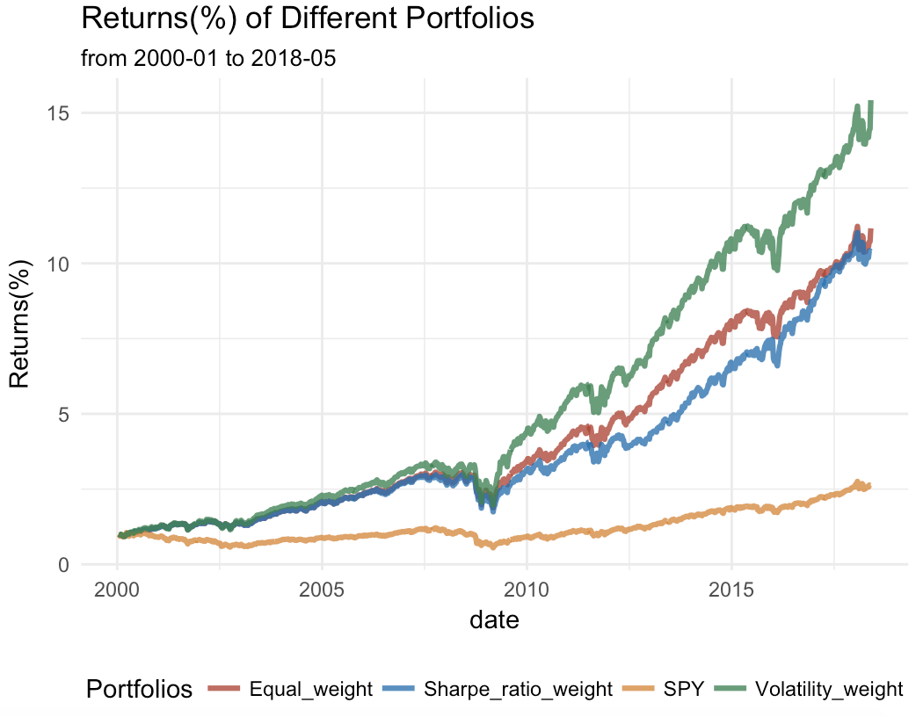

1. **Conclusion**

This strategy is consist of technical analysis indicator as well as a dynamically adjusted threshold for transformation between momentum and reversion style. Since the characteristic that this strategy can turn investment style when failure in investing high volatility stocks, a volatility based weight is suitable to construct a portfolio.